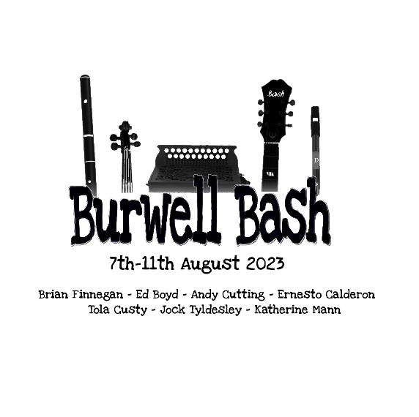
Please fill in this form to the best of your ability and add any details you think are necessary to help facilitate your application. Burwell Bash will shortlist candidates based on the information provided with the East Anglian Traditional Music Trust making the final decision. By filling in this application, you understand that if successful, you will not be able to apply for a further Ruddock Bursary in the future. If your application is successful, this bursary will entitle you to £250 off the price of your Burwell Bash ticket, you will be responsible for the remainder of the balance.

Name: |  | Date of Birth:
 |  | Current Age:
Address:

Sex/gender identity:
Ethnicity (not mandatory):

Disabilities, if relevant (not mandatory):

How long have you lived in East Anglia?
or
What links do you have with East Anglia?

Instrument(s) played: | Duration of learning:

Instrument(s) applied for at Burwell Bash:

While at Burwell Bash, what advantages, benefits and experiences do you think will benefit you to help develop your playing, style, technique, ability, or musicality?

Are there any holistic skills you believe that Burwell Bash would give you?

Are there any financial reasons or constraints that have also influenced this application?

Is there any additional information you would like to add that you feel would benefit your application?

